# **MINISTRY OF EDUCATION AND SCIENCE OF UKRAINE**

# **NATIONAL TECHNICAL UNIVERSITY**

# **«KHARKIV POLYTECHNIC INSTITUTE»**

# **Department of Software Engineering and Management Information Technologies**

Report from lab № 7

discipline «Algorithm and Data Structures»

Executed by: OUSSAMA BARKANE

Student of group KH-201.8ei.2

Checked by:

Prof.M . O.Bilova

Kharkiv – 2019

Theme : GEOMETRICAL ALGORITHMS (1 PAIR)

Objective: get acquainted with the basic geometric algorithms.

**Task:**

Develop a program that reads from the keyboard number N (1 <N <256) and Npairs of real numbers - the coordinates of points on plane. It executes an algorithm on them.

**Variants :**

5-Construct a convex hull using Jarvis' algorithm.

**Progress of the lab:**

Jarvis March algorithm is used to detect the corner points of a convex hull from a given set of data points.

Starting from a leftmost point of the data set, we keep the points in the convex hull by anti-clockwise rotation. From a current point, we can choose the next point by checking the orientations of those points from the current point. When the angle is largest, the point is chosen. After completing all points, when the next point is the start point, stop the algorithm.

CODE:

import java.util.Scanner;

import java.util.Arrays;

/** Class point **/

class Point

{

int x, y;

}

/** Class Jarvis **/

public class Jarvis

{

private boolean CCW(Point p, Point q, Point r)

{

int val = (q.y - p.y) * (r.x - q.x) - (q.x - p.x) * (r.y - q.y);

if (val >= 0)

return false;

return true;

}

public void convexHull(Point[] points)

{

int n = points.length;

/** if less than 3 points return **/

if (n < 3)

return;

int[] next = new int[n];

Arrays.fill(next, -1);

/** find the leftmost point **/

int leftMost = 0;

for (int i = 1; i < n; i++)

if (points[i].x < points[leftMost].x)

leftMost = i;

int p = leftMost, q;

/** iterate till p becomes leftMost **/

do

{

/** wrapping **/

q = (p + 1) % n;

for (int i = 0; i < n; i++)

if (CCW(points[p], points[i], points[q]))

q = i;

next[p] = q;

p = q;

} while (p != leftMost);

/** Display result **/

display(points, next);

}

public void display(Point[] points, int[] next)

{

System.out.println("\nConvex Hull points : ");

for (int i = 0; i < next.length; i++)

if (next[i] != -1)

System.out.println("("+ points[i].x +", "+ points[i].y +")");

}

/** Main function **/

public static void main (String[] args)

{

Scanner scan = new Scanner(System.in);

System.out.println("Jarvis Algorithm Test\n");

/** Make an object of Jarvis class **/

Jarvis j = new Jarvis();

System.out.println("Enter number of points n :");

int n = scan.nextInt();

Point[] points = new Point[n];

System.out.println("Enter "+ n +" x, y cordinates");

for (int i = 0; i < n; i++)

{

points[i] = new Point();

points[i].x = scan.nextInt();

points[i].y = scan.nextInt();

}

j.convexHull(points);

}

}

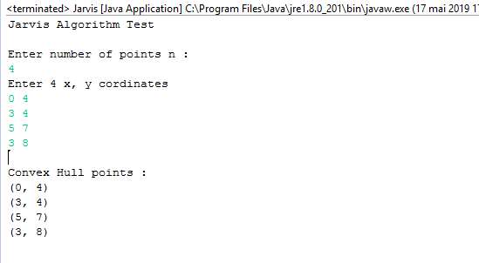

**Conclusion:**

In this laboratory the study of data structures was considered and implementing the basic geometric algorithms. Here is the source code of the Java Program to Implement a convex hull using Jarvis' algorithm.. The Java program is successfully compiled and run on a Windows system.